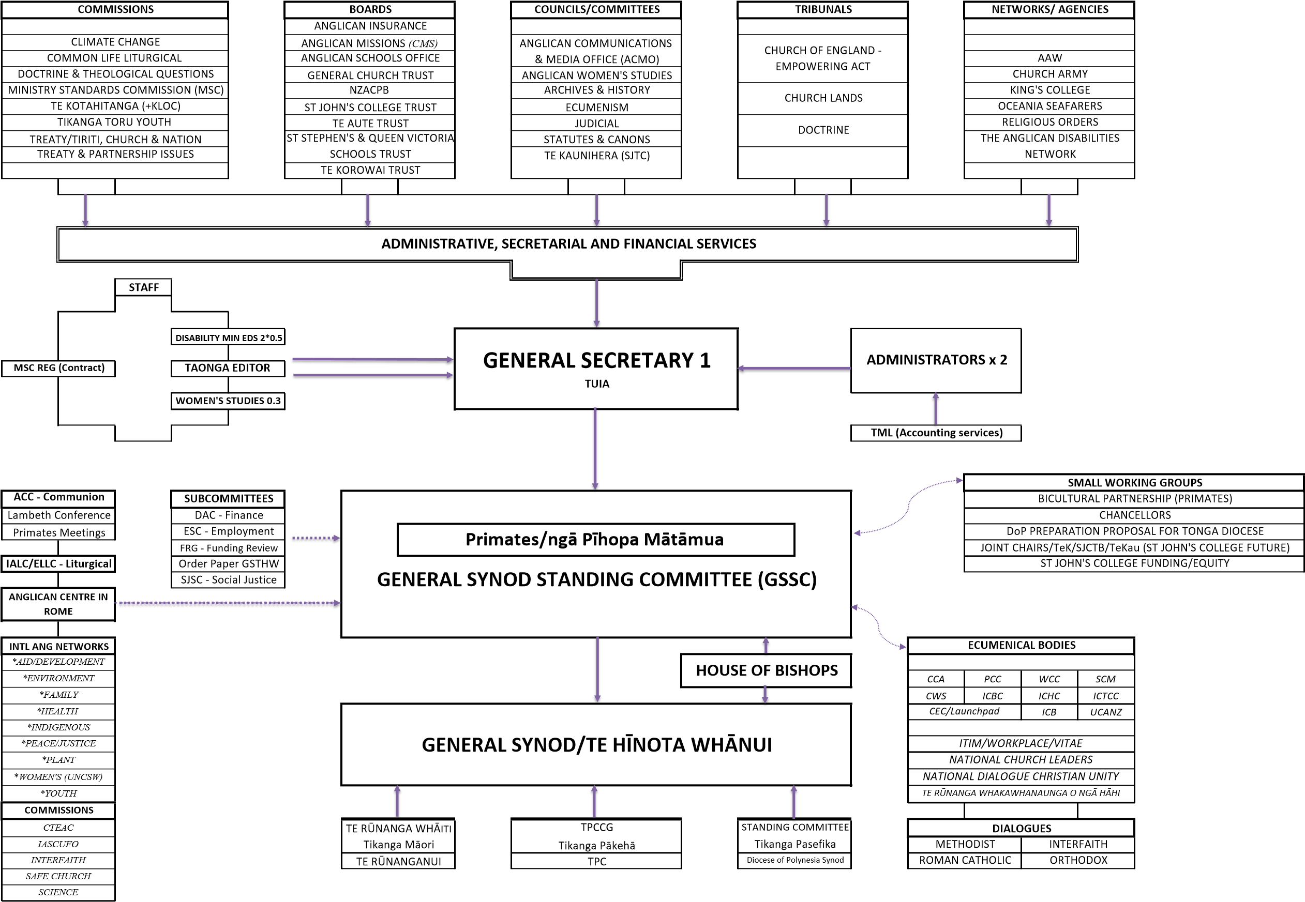
https://synod365-my.sharepoint.com/personal/m_alix_anglicanchurch_org_nz/Documents/Documents/Updated Organisational Chart @ 25JUN26

